CBTV Branding

Name_____________________________________________ Period__________

Just like any company, business or organization, Cypress Bay TV Production works hard to spread our brand. One method we do this is by t-shirts that are given to all members of CBTV. Using markers or colored pencils, create the 2014/2015 CBTV membership shirt.

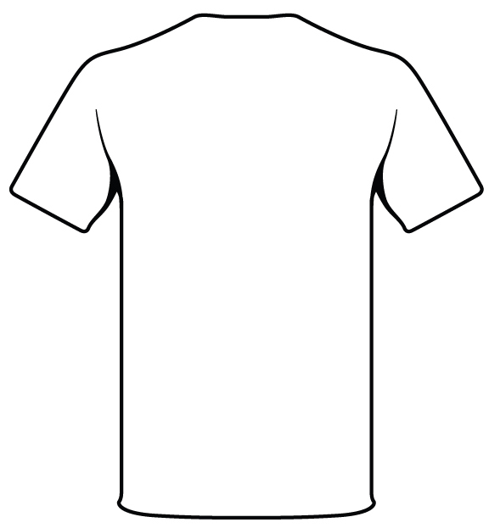
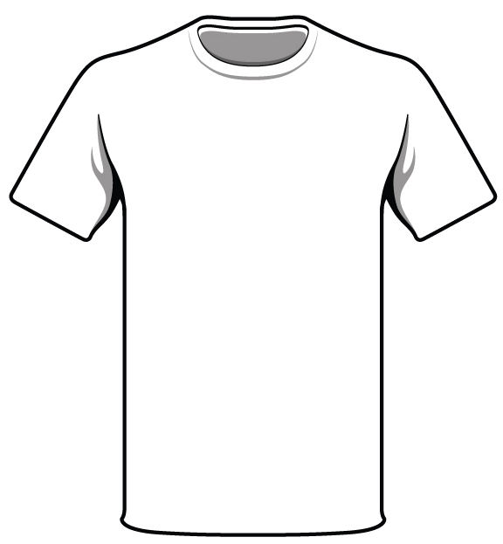

Branding in Business  Read the article attached.  1. How can promotional materials (such as t-shirts and  calendars) help a business?  __________________________________________________  2. What is a niche?  __________________________________________________  3. Give an example (different from the article) that illustrates how a business can use their niche when producing promo products.  __________________________________________________  4. Give a specific example of a local business who uses promotional products to advertise their brand.  __________________________________________________  5. What promo products do they produce/distribute?  __________________________________________________ | CBTV Branding  1. Besides the above t-shirt, name 2 other promo products CBHS CBTV can order/distribute to our members to promote our brand.  ____________________________________________  ____________________________________________  2. What do you think CBTV’s niche is at CBHS?  ____________________________________________  3. How can we use our niche when creating promotional products?  __________________________________________________  4. Besides promo products, how can we educate CBHS about  CBTV?  ____________________________________________  ____________________________________________

